л 35

**■ ■ PLAYERS**

Undercellars of the Dread



Destination

A 1st Level Adventure

In the days when Cormyr was little more than a coastal monarchy bordering miles of unclaimed woodland, followers

2-4

**HOURS**

**TIER!**

of Bane, the Black Hand, arrived by boat to Suzail Some remained in the capitol Others spread like a virus into the trees. All had been granted visions of a future Cormyr ruled by a succession of True Tyrants, each served body and soul by Unholy Champions and Dark Hands drawn from the ranks of

Cormyrean nobility. In feverish dreams Bane carried them up into the heavens to behold Cormyr’s armies spread out like fingers to grasp all the lands below. They saw kings and queens conquering and enslaving. When the fingers closed, the armies returned triumphant. They saw Cormyr become the blood red fist of Bane.

As Bane foresaw, Cormyr conquered and absorbed the outlaw kingdoms his followers had covertly fostered. Cormyr’s kings wed outlaw queens. The remaining royals and nobles of the fallen realms were married into Cormyrean noble families. But Cormyr’s Crowned Heads never came to embraced the teachings of the Black Hand. The outlaw kingdoms are to blame for this, as most fought and slew Banites wherever they found them.

The Banites of Suzail worked aggressively to encourage trade and forge mercantile alliances. Coin and laborers flowed into Suzail, the fresh converts to Bane’s cause hidden in plain sight. These followers disappeared soon after, that the Dread Destination could be carved from a mountain in the Stormhorns. The Banites had covertly pooled their wealth and resources to construct a tower fortress that could touch the sky. They had hoped to wrest control of the mighty castles of the giants floating above the mountain peaks, for if Cormyr would not follow Bane, then Cormyr would be conquered from above.

But the grandest dreams of gods and mortals oft fail to come true. The Dread Master of the tower fortress slew the Dodkong of the giants easily enough, but the power to summon the storm was not passed to her as foretold.

Indeed, the giant *was* the storm, a colossal maelstrom that engulfed the Dread Destination. Its floors and occupants were ripped apart and scattered for miles in every direction.

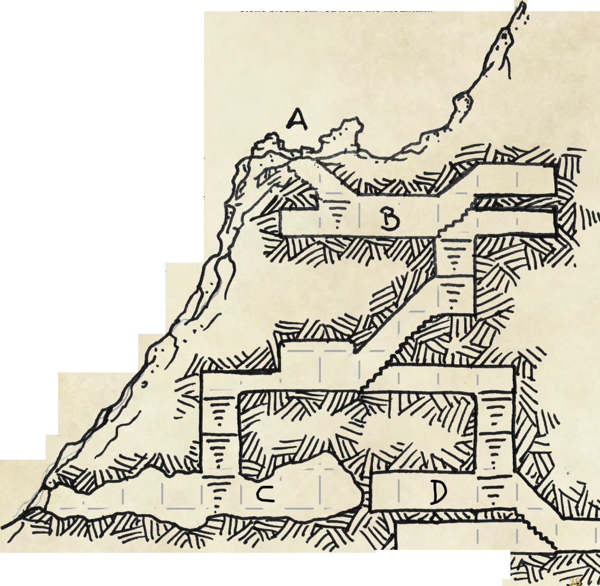Today, the remains of the crag from which the tower fortress had been carved resembles a broken fang, one that cuts the storm clouds that smother the mountain peaks. The wounded clouds cry frozen tears. The undercellars of the Dread Destination are never without snow.

This dungeon is divided into four Parts: А, В, C, and D. Each Part identifies a specific layer of the dungeon. The Area numbers start at 1 for each Part (e.g., Area Al, Area Bl, etc.).

Area **Al:** Cliff Ruin

The only visible remains of the tower fortress atop the fang­shaped crag is a roofless, rubble-strewn, snow-covered ground floor room bordered on its north and south sides by broken down walls, and a lonely, snow-covered stairway that sinks into darkness. The north wall rises 10 feet at its highest point, and appears to be made from black stone blocks carved from the mountain.

The remnants of the walls are scattered atop the cliff, their presence betrayed by lumpen shapes rising out of the four foot deep snow.

The wind moans like a wounded dragon as it winds its way between the mountain crags. When the storm clouds part, the view of the Stormhorns at this elevation is breathtaking— literally: characters not equipped with cold weather gear, characters not resistant or immune to cold damage, and characters not naturally adapted to cold climates, must succeed on a DC 10 Constitution saving throw or become stunned for 3 (ld6) rounds.

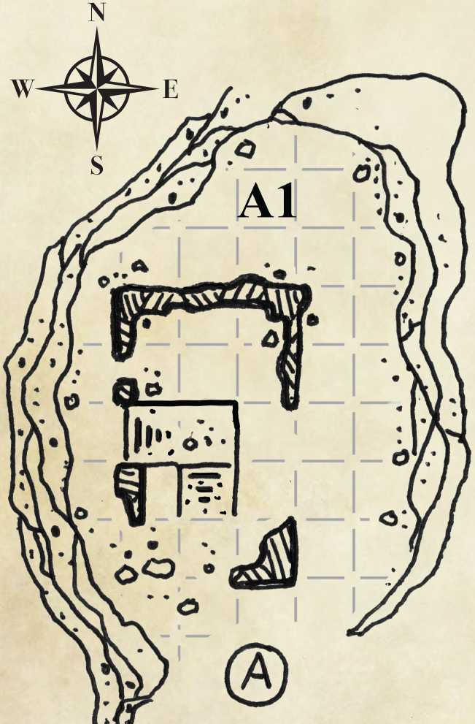The stairway is covered in a 4 foot thick layer of snow, and descends 10 feet at a sharp (45 degree) angle to a 10 foot square landing. Stairs on the south side of the landing descend another 10 feet. The hazardous stairway footing is complicated by broken stone scattered among the stairs that is hidden by the snow. The first time characters take the stairs, they must succeed on a DC 12 Dexterity (Acrobatics) check or fall prone. Characters that fail their check by 5 or more fall onto the rubble or down the stairs, and take 1 (ld2) hp bludgeoning damage.

Beyond the edge of the cliff, the mountain crag widens as it descends, forming a steep, snow-covered slope. Starting 100 feet below the landing, enormous black lumpen shapes half submerged in snow liter the mountainside.

Characters that attempt to climb down the mountain must succeed on a DC 15 Strength (Athletics) check. Characters that fail their check by 10 or more suffer a mishap: they fall 20 feet, suffer 7 (2d6) bludgeoning damage, and must succeed on a DC 13 Strength (Athletics) or Dexterity (Acrobatics) check to suspend their fall On a failed check, the character falls another 20 feet and suffers an additional 7 hp bludgeoning damage. The checks repeat until the fall is suspended or the character dies.

Characters that explore Area Al after sunset risk being attacked by 1 **wyvembeast** from Area C2.

dungeon information

Map Square 10 foot squares.

Ceilings 10 feet high. Smooth, finished stonework.

Doors Black granite mounted on stone sockets.

Brass pull rings. VERY noisy when opened.

Default: unlocked. Burst DC 2 5.

Dungeon 10,123 feet at Area C3.

Elevation

Floors 4 foot square flagstones, black in color, mortared together over finished rock.

Stairs 45 degree angle. Double movement cost. Alternating black and red granite steps laid down over finished stonework.

Walls Smooth, finished stonework.

ENVIRONMENTAL hazards (DMG p.110)

Type Effect

Extreme Cold: Daytime temperature: 20 degrees

Layer A Fahrenheit. Nighttime temperature: 0 to -20 degrees Fahrenheit. Characters without access to a constant source of heat and cold weather gear gain no benefit from short and long rests on this level.

High Altitude: Characters that are active* for more than 4 Layer A hours on this dungeon level must make a Constitution saving throw. The DC is 10 + 1 for each hour past 4. On a failed save, the character suffers 1 level of exhaustion.

Extreme Cold: The temperature remains a steady 40 Layers B, C, D degrees Fahrenheit. Characters must have access to a constant source of heat or to cold weather gear, or they gain no benefit from short and long rests on this level.

High Altitude: Some of the *portals* circulate air from Layers B, C, D lower elevations into the dungeon.

Characters that are active for more than 6 hours on these dungeon levels must make a Constitution saving throw. The DC is 10 + 1 for each hour past 6. On a failed save, the character suffers 1 level of exhaustion.

[ * ] Characters that rest or perform non-strenuous activities are not considered to be active.

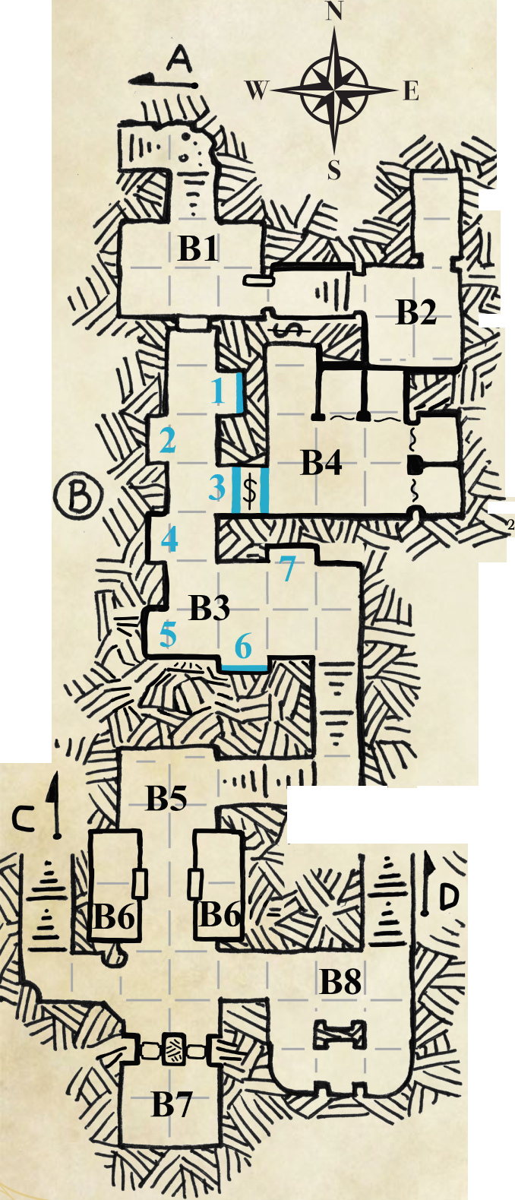

Area Bi **:** Entryway

**DREAD DESTINATION**

Two featureless, lockless doors of black stone with brass pull rings gone green from corrosion are set one each into the south and east walls of this 30 foot wide by 20 foot long chamber. The door in the eastern wall is open.

The flagstones are stained from decades of snowmelt. Layers of mineral deposits spread out from the foot of the stairs like frozen ripples in a pond. (Even at this elevation snow can melt, which it has from time to time over the last 600 years).

A sound like growling earth elemental emanates from the door in the south wall if it is opened. The noise is a feature of the undercellars, not an error of architecture. Within the coldly correct hierarchy of the Dark Destination, the Adjunct to the Undercellars was master of everything in the mountain. One could not simply walk about and open doors at will unless they were a high priest or the Dread Master of the tower. The adjunct kept a strict schedule of guard rotations and assigned duties. The unscheduled sound of a door being opened meant someone had failed to adhere. This brought punishment of the kind the adjunct was only too eager to mete out.

Area **B2:** Chamber of the Adjunct

A short hallway leads to a set of stairs that rise 10 feet up to a 0 foot square chamber. An archway in the north wall of the chamber opens into a 20 foot long by 10 foot wide space.

The stairs served to catch the attention of visitors to the adjunct, making it easy to miss the secret door set into the south wall of the hallway. Characters with passive Perception scores of 15 or higher will notice the outline of the secret door. Characters that search the short hallway find the secret door with a successful DC 13 Wisdom (Perception) check. The door opens inward if pushed, and without noise thanks to an ancient layer of grease applied to its stone sockets.

Within the adjunct’s chambers, the south wall is equipped with a 3 foot tall bookshelf, a long table and a sleeping bunk, all carved from the same ironwood tree. The furniture is aged, but sturdy. The east and north walls lack furnishings. The bunk holds a shrunken mattress of burlap filled with moldered straw. If characters search the bunk, they discover a sheathed dagger fastened to the underside of one side rail (no ability check required). The dagger is of dwarf make: folded steel sharp as a dragon’s claw, the blade oiled and free of rust.

Among the items on the bookshelf are three matched tomes, the black fist of Bane burned into their leather bindings. If the characters inspect the tomes, they discover the middle book is made from blank pages that have been hollowed out. Within the hollow are two triangle shaped black stones; these are **ward tokens** linked to the ward in area B3. A character with the Sage background may be interested to know two of the books contain writings by Scyllua Darkhope (Rightful Champion of Bane), Aumarrath the Tyrant-King (an early prophet of Bane), Zana’eesh Harper Slayer, and other noteworthy Dark Hands.

A set of 10 flat tomes with spines of brass made to unfasten so new sheets of parchment can be placed into them are stacked on the bottom layer of the bookshelf. These were the adjunct’s logbooks.

A cold layer of dust blankets the table surface and the objects atop it: a small iron key, a jar of dried black ink and a shriveled feather quill

The narrow chamber holds four sets of empty iron manacles on the east wall The adjunct personally dispensed punishments to undercellar occupants that failed to heed his orders. The key to the manacles rests on the table in this room. It is a master key, and opens all the manacles in Layers В and C of the undercellars.

Crazed Wizard

*Medium humanoid (human), chaotic evil*

Armor Class 14 (17 with *mage armor)*

Hit Points 32 (5d8 + 10)

Speed 30ft.

STR DEX CON INT WIS CHA

10 (+0) 14 (+2) 14 (+2) 16 (+3) 13 (+1) 11 (+0)

Skills Arcana +5, Perception +3

Senses passive Perception 1 3

Languages Common, Chondathan

Challenge 1 (200 XP)

*Unpredictable.* The crazed wizard moves about uncontrollably. +2 AC.

*Spel****l****casting.* The crazed wizard is a 4th-level spellcaster. His spellcasting ability is Intelligence (spell save DC 1 3, +5 to hit with spell attacks). He has the following wizard spells prepared:

Cantrips (at will): *burning hands, mage hand, prestidigitation, ray of frost*

1st level (4 slots): *disguise self fog cloud, mage armor, witch bolt*

2nd level (3 slots): *gust of wind, Melfs acid arrow, misty step*

Actions

*Dagger. Melee Weapon Attack:* +2 to hit, reach 5ft., one target. *Hit* 2 (1d4 + 0)

Area Вз: Portal Nexus

**NOTE:** Characters traveling through the portals in *Dungeon Under the Tower Keep* and *Dungeon Under the Pond* emerge into this Area.

A hallway runs 60 feet south from the door to Area Bl, then turns east for an additional 30 feet. Alternating niches set into the walls hold *portals* that shed dim light. The inactive portals resemble lonely door frames absent a door. Each portal is numbered in sequence on the dungeon map for Layer B.

A stairway in the southeast comer of Area B3 descends 20 feet to a landing that turns west, where a second stairway descends an additional 20 feet to an opening in the northeast wall of Area B5.

|  |  |  |
| --- | --- | --- |
| Portal Table | | |
| Number | Status | Destination |
| 1 | Active | *Dungeon Under the Tower Keep* |
| 2 | Inactive | N/A |
| 3 | N/A | Warded Secret Passage |
| 4 | Inactive | N/A |
| 5 | Active | *Dungeon Under the Pond* |
| 6 | Malfunctioning N/A | |
| 7 | Inactive | N/A |

**Portal 3** is a false portal A ward placed in the passage connecting Area B3 to Area B4 mimics the appearance of the other portals. Creatures that pass through the ward from either side without carrying the proper ward token must succeed on a DC 13 Constitution saving throw or become paralyzed for 10 (2d 10) rounds. Characters that succeed on their saving throw are stunned for 1 round. The ward prevents light and sound from passing between Area B3 and Area B4.

**Portal 6** appears active, but it has no destination. The last creature to use the *portal* was a duty wizard of the undercellars who'd disobeyed orders to remain at his post when the fortress tower came under attack. He stole all he could from the bunks of his fellow duty mages, then fled through portal 6 at the same moment the link between the portal and its destination was severed. For 600 long years the wizard could see where he came from, but had not the means to escape. He went insane a long, long time ago.

If a creature uses portal 6, it becomes trapped. While trapped, a creature stops aging and has no need for food, drink or sleep. If a creature is trapped inside portal 6 when another creature uses it, the trapped creature is ejected into the square adjacent to portal 6 and falls prone.

Upon his return, the **crazed wizard** ignores characters that attempt to communicate with him or help him. Roll initiative. On his turn, the duty wizard attempts to slay all living creatures he can see. The wizard absolutely *will not* go into another portal, even to save his own life.

**Equipment:** ward token, strongchest master key, large wrought iron key, two spellbooks, one pouch (material components^ one arcane focus, three *potions of healing,* one waterskin (full), 65 sp, and an explorer's pack (PHB p.151)

**Spellbook 1 Contents**

1st level - 8 spells (8 pages): *Alarm, Fog Cloud Identify, Illusory Script, Jump, Sleep, Tasha's Hideous Laughter, Unseen Servant.*

2nd level - 6 spells (12 pages): *Flaming Sphere, Hold Person, Melf's Acid Arrow, Misty Step, Ray of Enfeeblement, Scorching Ray.*

3rd level - 2 spells (6 pages): *Glyph of Warding, Sending.* (Formulae - 21 pages) Formula for crafting a *Wand of Magic Missile.* 53 blank pages.

**Spellbook 2 Contents**

1st level - 5 spells (5 pages): *Alarm, Disguise Self, Fog Cloud Mage Armor, Witch Bolt.*

2nd level - 5 spells (10 pages): Gust *of Wind Knock, Melf's Acid Arrow, Misty Step, Ray of Enfeeblement.*

85 blank pages.

Area **В4:** Duty Wizards' Quarters

The secret door in the north wall, and the warded entrance in the west wall, prevent light and sound from escaping this 40 foot wide by 30 foot deep chamber. There are no oil lamps, torches or other obvious sources of light (or heat). Frayed black curtains hang from brass rails attached to the ceiling in the north and east walls. Behind the curtains, a wooden bunk, strongbox (2 foot square by 1 foot deep lidded container, with reinforced comers and lock) small table and three-legged stool fill each of four 10 foot square bunkrooms.

The ironwood furniture is in disarray: bunks flipped over, mattresses cut open, tables on their side, strongboxes emptied. Characters that inspect the southeast bunkroom notice its strongbox is closed; if turned right side up, its contents shift and rattle. This strongbox is locked. A DC 13 Dexterity check using thieves' tools is required to pick the lock.

When the strongbox is opened, the ringing sound of a hand bell fills Area 4 for 10 seconds. Inside are one *potion oi healing,* one spellbook, a large and malformed brass key, a carving knife, a small block of moldered cheese (perfectly edible if the mold is cut away) and a pouch of ball bearings.

If the spellbook is opened, a *Magic Mouth* appears on the cover. The cold, calculating voice of a woman is heard by all, *"Petty theft is beneath a servant of Bane. Your punishment will be slow, agonizing and final"*

**Spellbook Contents**

1st level - 6 spells (6 pages): *Alarm, Comprehend Languages, Feather Fall Grease, Illusoiy Script, Identify.*

2nd level - 2 spells (4 pages): *Cloud of Daggers, Magic Mouth.* 3rd level -1 spell (3 pages): *Fireball.*

87 blank pages.

Area **B5:** Gate Hall

At the north end of the gate hall, the east and west walls turn inward for 5 feet, each forming part of the north wall of a gatehouse. A portcullis hangs half open in the gap between the gatehouse walls. 20 feet beyond the portcullis, a second portcullis prevents passage to the south end of the gate hall. Two identical stone doors face-off between the portcullises. Each is closed.

The south end of the hall is formed of an intersection. To the east, a 10 foot hallway leads to a shrine. To the west, a 20 foot long hallway ends at a stairwell that descends 30 feet to Layer C. To the south, a pair of floor-to-ceiling, iron shod stone doors with blood red fists painted on them suggest it is easier to go in another direction.

Area **Вб:** Gatehouse

Two stone doors, currently shut, open into identical gatehouses that served double duty as guard barracks. Each door opens inward to reveal a narrow ironwood table set against the wall opposite the door. A bench beneath the table sat six guards at a time. A wrought iron stand holding a glass bowl filled with oil and a wick graces the table. The table lamps are well preserved and shed light in a 15 foot radius if lit. (15 gp each; bowl holds 4 pints of oil) Triple-tiered bunks line the north and south walls. A total of 24 soldiers lived and slept here in shifts.

A thick iron hand crank is set into the wall near each door. The hand crank in the eastern gatehouse operates the north portcullis. The hand crank in the western gatehouse operates the south portcullis

A large wrought iron key is secured to three pegs set into the back of the door to the eastern barracks room. If the characters compare this key to the one carried by the crazed wizard from portal 6, they observe the keys are of the same material and size, but the teeth of the keys differ.

Area **B7:** Armory

Blood red fists as tall as a human decorate the surface of the two iron shod stone doors fronting this chamber. Two different keys must be inserted one each into keyholes within the red fists. The senior duty mage (trapped in portal 6) carries the key for the east door. (A poorly made—but useable —copy of the east door key is located in the locked strongbox in Area B4.) The west door key is found in Area B6.

The locking mechanism is spread between both doors and the interior of the stone monolith to which the doors are attached (see map) **Two characters** using thieves' tools must simultaneously succeed on a DC 20 Dexterity check to unlock the doors. Burst DC 30. Opening either door sends a rumble like the warning growl of an angry dragon throughout Layer В that can be heard as far away as the adjunct's chambers.

The interior walls of this 20 foot square chamber are dominated by iron racks holding battleaxes, flails, serrated daggers, spears, morningstars, crossbows, barb-tipped crossbow bolts, warhammers with fist-shaped hammer heads, spiked shields, and iron mannequins wearing suits of chainmail and razor-edged plate armor.

In the center of the armory, a barrel-sized vat of black stone is filled to the brim with a dung-brown fluid. Ripples flow like time reversed over the liquid, each peak and trough forming at the perimeter of the vat and then flowing inward to oblivion. A 1 inch thick round lid of black stone rests against the vat.

The vat holds pure liquid anathema to all giant kind: Giantbane poison. *Identify* allows a character to determine the nature and effect of the liquid. Priests of Bhaal (see Layer D) worked for decades to procure and mix the ingredients necessary to create the Giantbane. They filled the vat infrequently, one cup at a time.

Area **B8:** Shrine to Bane

This 30 foot square chamber is dominated by a 20 foot tall altar to Bane, the Black Hand. The high ceiling is domed; the altar joins with the ceiling over the center of the chamber. Two renderings of Bane are worked into the surface of each side of the altar: Bane in all His brutal glory on the north side, and Bane seated upon the Throne of the One True Tyrant on the other. A niche in the south wall holds a smaller throne, one reserved for the exalted backsides of priests from higher up in the tower when they deigned to oversee worship in this chamber. In the northeast corner, an opening in the wall heralds a stairway that descends 30 feet to Layer D.

Daily worship of Bane was of course mandatory for the occupants of the Dread Destination. The occupants of the undercellars worshipped here in shifts.

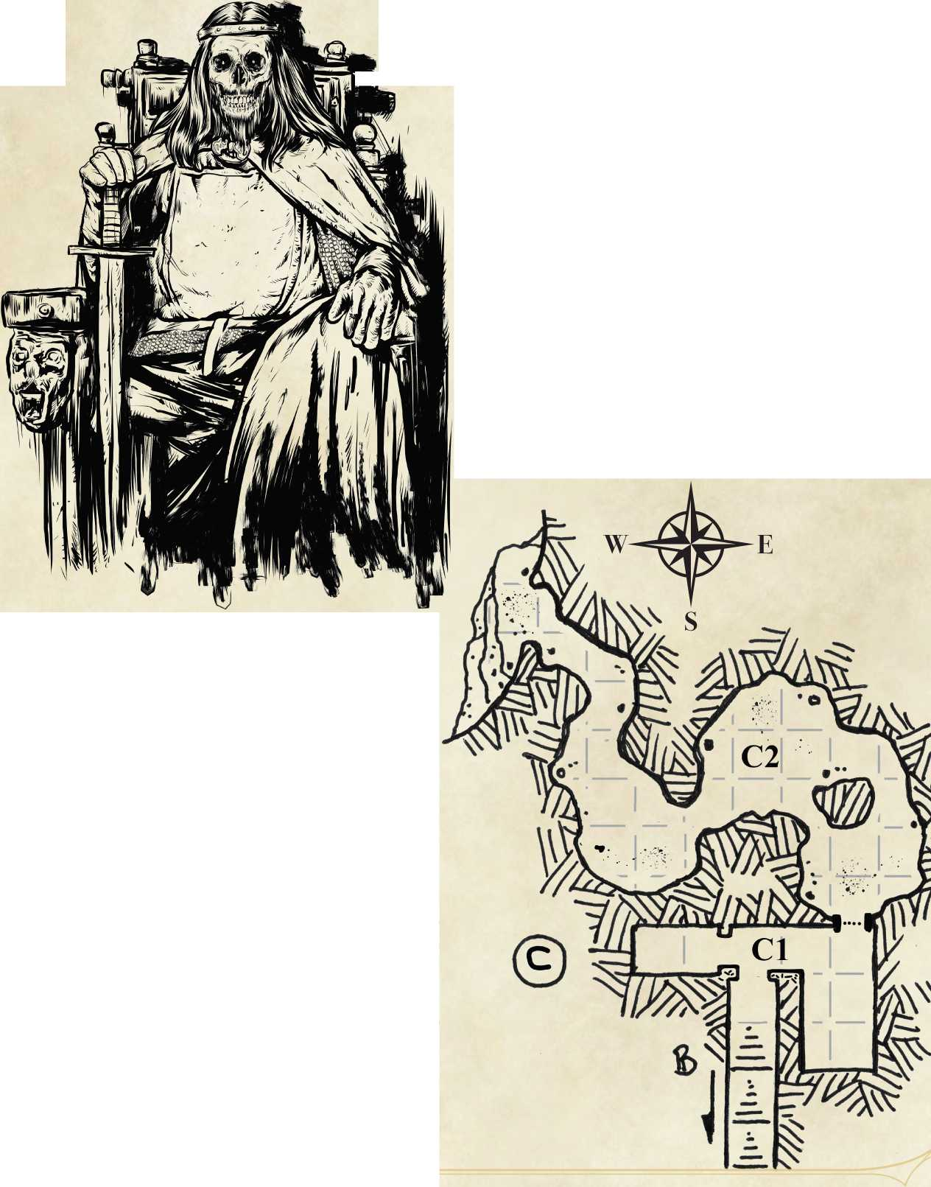A corpse sits on the lesser throne. It appears to have been posed. Its clothes, armor, sword and hair are unusually well preserved. A palpable aura of unholy power is felt by any creature within 10 feet of the throne.

N

Area Сі: Food Storage

30 feet below Layer B, the stairs open into a short east-west hallway. 20 feet to the east stands a 30 foot long by 15 foot wide chamber. To the west, an archway fronts a privy.

The severity of the attack on the Dread Destination left no doubt in the adjunct’s mind that it was doomed to destruction. The adjunct had rushed to the shrine and kneeled before the altar to offer his soul up to Bane that it be used to prevent the tower fortress from being destroyed.

Bane accepted the sacrifice and made a shield from adjunct’s soul The power of a soul freely given is tremendous, but not infinite. The adjunct’s devotion preserved the undercellars, less the damage already done. The tower above was not protected.

Bane’s power carried the adjunct’s lifeless corpse to the small throne, and preserves it to this day. The adjunct’s corpse remains a silent testament to unswerving loyalty.

Characters that damage or deface the corpse reserve for themselves the dark attention of Bane. Followers of the Black Hand are sure to visit the offending characters at a most inopportune time in the future.

Servants within the tower fortress hauled chamber pots down into the undercellars and dumped them over holes carved into the flagstones lining the floor on the north and south walls of the privy. The servants’ terrible aim while emptying their burdens (and their bowels) in this room served to remind the adjunct that not even he possessed the authority to punish them.

The Banites kept slaves, captured enemies and kidnap victims (mostly from Cormyr) manacled to the south and west walls in the eastern half of Area Cl. The restraints—still in working order—hold no prisoners when the characters first arrive here.

Instead, prisoner corpses litter the flagstone floor, their arm and wrist bones having long ago failed to support the dead weight. An iron hand crank forged like a ship’s wheel is set into the northeast wall Turning the crank raises a portcullis in the northeast wall

Guards opened the portcullis and allowed one wyvernbeast at a time inside to choose a non-spellcasting captive to stab. The guards unlocked the dying captive and the wyvernbeast hauled them back into C2 for a meal

Wyvernbeast

*Medium beast, neutral evil*

Armor Class 12 (Dex) Hit Points 9 (2d8 + 0) Speed 10 ft., fly 50 ft.

STR DEX CON INT WIS CHA

10 (+0) 14 (+2) 10 (+0) 6 (-2) 12 (+1) 12 (+1)

Damage Resistances cold

Senses: darkvision 120 ft., passive Perception 1 3

Languages: Can't speak.

Challenge: 1/2 (100 XP)

*Keen Senses.* The wyvern beast has proficiency in the Perception skill.

*Innate Spel****l****casting.* The wyvern beast's innate spellcasting ability is Charisma (spell save DC 11, + 3 to hit with spell attacks).

At will: *booming blade, lightning lure* (SCAG p.142, 143)

2 1st-level spells/day: spells vary by individual.

*Sunlight Sensitivity - Moderate.* While in sunlight, the wyvernbeast has disadvantage on attack rolls and ability checks.

Actions

*Talon. Melee Weapon Attack:* +2 to hit, reach 5 ft., one target. *Hit:* 2 (1d4) piercing damage.

Area **C2:** Aerie of the Wyvernbeasts

Absent a natural ability to fly or to move about by means of magic, the Stormhoms cannot be easily explored. And while giants were the ultimate target of the Dread Master, she was not ignorant of the many dragons and other powerful creatures lairing in the vicinity of the Dread Destination. She ordered the winding cave comprising Area C2 to be set aside for the creation and feeding of Wyvernbeasts, the later to be used as unswervingly loyal scouts and lookouts.

Captives from Area Cl transformed into wyvernbeasts were made to breed with the resident corruption in Area C2 *(Corruption* is the collective noun for a group of wyvernbeasts.) Since the fall of the tower fortress, wyvernbeasts have multiplied and spread across the high crags of the Stormhoms.

**5** descendants of the original cormption still live in the aerie. They have become resistant to cold, their wings larger, their bodies lighter, their senses the equal of any aerial predator. Unlike their ancestors, spells are not imprinted in these wyvernbeasts. Rather, their spells manifest when they reach maturity, the magic resembling that of a sorcerer and not the arcane power of the duty wizards that first bred them.

The first of the five wyvernbeasts alights atop Area Al after sunset. It waits until its kin have flown far down the mountain before it starts its own hunt.

Wyvernbeasts resemble shmnken wyverns papered over in lizard skin. Though similar to the darkenbeasts utilized to devastating effect by the Red Wizards of Thay, wyvernbeasts are made from captive humanoid spellcasters and not creatures of the Beast type.

Fully extended, a wyvernbeast's wings can reach from one side to the other of a 10 foot square, each sporting one dagger-length talon mounted on the first wing joint. A similar talon grows from its tail The skeleton of a wyvernbeast (including talons, fangs and claws) glows in vivid hues of purple, green, blue, and (rarely) silver when it casts spells, or while in the presence of strong magic. This effect is visible through its thin skin.

Wyvernbeasts are nocturnal hunters that fly down the fangs of the Stormhoms to skewer unsuspecting creatures with their talons. They return to their lairs well before sunrise. They avoid sunlight at all costs.

**Solitary Feeders.** If a wyvernbeast drops a character to 0 hit points, it drags the fallen character to the part of the aerie the wyvernbeast has claimed for itself.

**Savvy Predators.** Wyvernbeasts learn to use their spells to assist with stalking and slaying prey. For example, wyvernbeast #1 uses *thunderwave* to knock creatures off of mountain crags, then it retrieves the corpse. Wyvernbeast #3 uses *disguise self* to appear like its prey in order to get close, then attack.

**Innate Spellcasters.** Wyvembeasts can cast two cantrips at will, and up to two 1st level spells per day drawn from the Sorcerer spell list. Cantrips are typically the same for each wyvernbeast in a cormption, while 1st level spells vary by individual Their magic echoes the environment the cormption lives in.

**lst-level Spells by wyvernbeast (5):**

1. *Charm Person, Thunderwave*
2. *Magic Missile, Sleep*
3. *Disguise Self, Ray of Sickness*
4. *False Life, Fog Cloud*
5. *Burning Hands, Silent Image*

Area **Di:** Special Punishment

The stairs here mirror those of Area Cl. They descend 30 feet from Layer В to a T-shaped intersection. Through the archway to the west is a privy. To the east, stairs descend 10 additional feet to a cross-shaped chamber. Manacles for neck, hands and feet are set into the north, east and south walls. The north wall is an illusion; the manacles within the wall are real enough, but they are attached to a wrought iron rack sporting two oiled wheels (not unlike a real world dolly or box cart) hidden inside the illusion.

Priests of Bane are not above punishment. Within the Dread Destination a priest's status afforded them their own space in which to suffer. The first kind of suffering came from elevation: imprisonment at the bottom of the undercellars was akin to being lowest in rank—a position no sensible Banite wanted to be in. The second kind occurred when a Banite was sucked into the walls, manacles and all Observing one of their number howling for mercy as they disappeared into oily black stone was usually all it took for misbehaving Black Hands to amend their behavior.

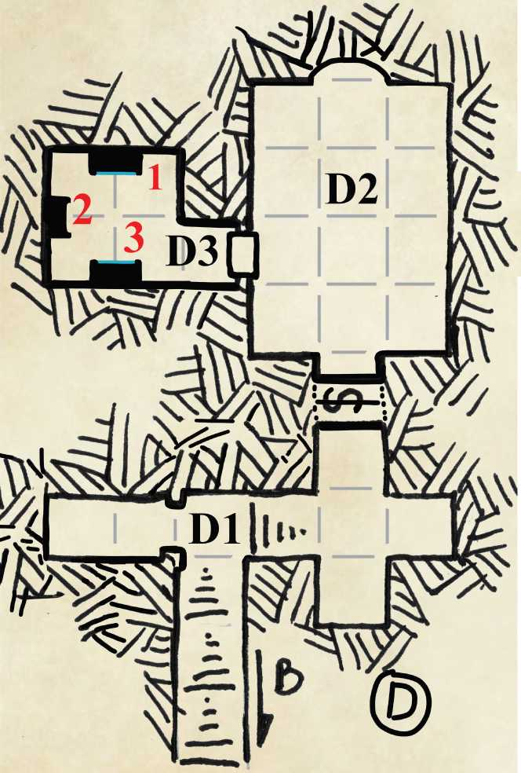Area **D2:** Hidden Temple

Upon seeing this chamber, any hope of salvation a Banite might have entertained evaporated the instant they realized they were in the hands of the followers of Bhaal

The temple is 40 long by 30 feet wide. There are no visible exits, but for the stone door with a round brass ring handle in the west wall An alcove in the north wall is covered over in smooth black tiles that glimmer in torchlight. The handles for the iron prisoner rack extend into this room from the alcove in the south wall where the illusion cloaking the passage between Area DI and D2 is located.

The illusion is one part of the ward that fills the passage. The passage is also warded by an effect that prevents sounds, smells, sudden bursts of air, and light from crossing between Area DI and Area D2.

The iron prisoner rack is heavy. It required two of the six Doombringers that worshipped here to move it, and any prisoner manacled to it, about the temple space.

Characters that attempt to move the rack find it is silent (bone grease on the rack’s wheel axles still works).

If a creature offers prayers to Bhaal while occupying the square adjacent to the alcove in the north wall, the spaces between the tiles ooze blood that coalesces into several thumb-sized drops that begin to turn counterclockwise. More blood forms the outline of a humanoid skull within the turning circle. This is the symbol of Bhaal, Lord of Murder. It remains for 1 hour after prayers are rendered.

**W**

When Doombringers were not worshipping in this temple, they taught the ways of murder to acolytes in training, and to followers Bhaal brought here from all over Cormyr. The captive priests of Bane were put to good use.

The door from Area D2 opens into a 10 foot square entryway. Beyond the entry, a 20 foot square chamber hosts three massive stone monoliths of black granite. Rippling blue fields of magic that resemble suspended sheets of water play across the face of two monoliths, bathing the nexus in a muted blue radiance.

Area **D3:** Hidden Nexus

The exits for portal 1 and portal 3 are blank walls. Neither exit sports a frame, arch, or any other construction that suggests a *portal* is present. To return to Area D3, one need only square up with a given wall and walk into it.

Portal Table

| Number | Status | Destination |
| --- | --- | --- |
| 1 | Active | The Old Man |
| 2 | Inactive | N/A |
| 3 | Active | Trolldoom Manor |

**Portal 1** exits into a cramped space accessible by a secret door set into the back wall in the jakes of the Old Man. A cozy, quiet tavern popular among retired Purple Dragons and the elderly residents of Waymoot, and referred to by locals as "the little labyrinth" for its many secret passages, the Old Man’s fireplaces are kept lit day and night. The tavern is filled round the clock with guests that sip brandy distilled locally, and trade stories of the many conflicts seen by the battle- scarred shields that cover the tavern walls and the heroes that once carried them.

**Portal 3** exits from an interior wall in an outbuilding of Trolldoom Manor, "Trolldoom" being the name given to the ancestral family home of House Irlingstar by the founder of that House. Any living Irlingstar will tell you the name is more of a promise made than a fact of troll battles previously fought and won in the vicinity of Waymoot.

The Irlingstars have no idea this *portal* exists, though it is not the only *portal* to be found on their lands. The presence of armed novice adventurers will elicit a swift armed response should the characters be discovered. Some measure of diplomacy is necessary if the characters wish to avoid bloodshed and the earning of a new, powerful enemy.

(Characters with the [Noble background](https://www.dmsguild.com/product/281781/Eye-on-Cormyr-2-Nobles-of-Cormyr%20.) know that the Irlingstars have a reputation as pleasure-seeking dandies that avoid having to do much work, but they are capable of fighting as hard as any noble to protect what is theirs.)

The Doombringers of Bhaal did not keep residences within the Dread Destination; they lived elsewhere in Cormyr. Most were foresters that raised large families, taught the Dark Lessons to their followers, and prayed daily to the Lord of Murder for guidance in protecting the plants and creatures living in the trees that the deity had commanded to be preserved at all costs. They and their followers were Bhaal's eyes and ears in the Forest Kingdom. Through them, Bhaal came to see all of Cormyr for what it truly was—a garden that had gone to seed. Originally tended by the mighty dragon Thauglor, the Land of the Purple Dragon had been sown from end to end with things useful to the dragon. Not merely seeds, though there were plenty of those, but rare insects, beasts, monstrosities, and ancient forms of living magic. After Thauglor's defeat, the elves of the Lithtlom tended to the forest, not realizing the hidden potential in all they had won from the dragon. But Bhaal did. Soon after humans gained the power to rule Cormyr from the elves, the Lord of Murder saw what the Purple Dragon of old had planned, and the god smiled at the murders soon to come.

XP and Treasure Summary

This section omits mundane items the characters may find during the adventure unless the items are of significant value.

XP by Area

|  |  |  |  |  |
| --- | --- | --- | --- | --- |
| Area Creature (#) | | Monster XP | Total | Difficulty |
| A1 | Wyvernbeast (1) | (Included with C2) | (Included with C2) | Easy |
| B3 | Crazed Wizard (1) | 200 XP | 200 XP | Medium |
| C2 | Wyvernbeast (5) | 100 XP | 500 XP | Deadly |
|  |  | TOTAL: | 700 XP |  |

|  |  |
| --- | --- |
| **Treasure** Area Coins/Gems | Items |
| B2 | Masterwork dagger (30 gp value) Set of 3 tomes (10 gp value) |

B3 65 sp 3 *potions of healing, 2* spellbooks

1 explorer's pack, 1 arcane focus (rod)

B4 1 *potion of healing*

1 spellbook

B7 Giantbane [1]

C2 50 cp, 5 50 Small hand mirror engraved with sp, 3 5 gp *"Never Forget the Summer Court”* on its back (2 5 gp).

**[1]** Convincing anyone this is really Giantbane, much less finding a buyer, is an adventure in its own right. The Crown of Cormyr will of course investigate if word spreads that real Giantbane is on the market. If the characters manage to sell a quantity of Giantbane, the balance of power in Cormyr may well shift if giants are poisoned with it. The surviving giants will track down the source of the poison and make certain it harms none of their kind again. Other giants may seek to steal it for their own nefarious ends.

Equipment of Interest

Giantbane

Giantbane only effects creatures of the Giant type. It readily clings to weapons, shields and armor, and may be delivered by contact or injury (poisons, DMG p.257). Exposure causes a giant to suffer the poisoned condition (PHB p.292) Each round after exposure, a giant suffers damage equal to their average hit points per hit die, plus Constitution modifier. E.g., A storm giant suffers 6 + 5 = 11 hp poison damage per round, starting one round after exposure.

Effects that remove conditions, neutralize poison or confer poison immunity have limited effect on Giantbane. If the effect was a spell (including spells cast from magic items) the effect provides a temporary respite for a number of rounds equal to the level of the spell used to create the effect. Thus, the 2nd level spells *Lesser Restoration* and *Protection from Poisons* remove the poisoned condition from a giant exposed to Giantbane for two rounds.

If the effect was a magic item, such as the poison immunity granted by a *Periapt of Proof Against Poison* (DMG p.184) the magic item confers only 1 hour of respite per day from the deleterious effects of Giantbane.

A *Wish, Miracle,* or a blessing granted by a deity removes Giantbane.

Ward Token

This object is linked to a specific magical ward. Any creature that carries the token while passing through a ward's space is unaffected by some or all of the ward's powers, as specified in the ward's description.

Both magical and non-magical objects can be linked to a ward. Most ward tokens are small, non-magical, and bear a rune or other mark that indicates the ward token's purpose.

Running the Adventure

The encounters at Al and B3 are designed to challenge exhausted and/or wounded adventurers freshly arrived from another dungeon environment. If the characters are rested and at full hp when they arrive in the undercellars, feel free to add an additional wyvernbeast to Al (mayhap wyvernbeasts hunt in pairs before they mate each year) or pack a trio of guards (MM p.347) in with the trapped duty mage in portal 6.

The wyvembeast encounter in Area C2 is designed to be run as a gauntlet. The wyvernbeasts attack in waves of one or two at a time, **not en masse.** Characters have the option to retreat and close the portcullis between Cl and C2, so let them battle as far into C2 as they dare to go.

Because each wyvernbeast has claimed a space for itself inside the winding cave, the treasure for Area C2 is spread out, not lumped together in one spot.

Further Adventures

The *portals* marked inactive in this adventure need not be. If you want to link the Dread Destination to another adventure you're planning to run in Cormyr or the wider Realms, then by all means do so. Perhaps a special key in the form of a mundane or magical object is required to awaken a seemingly inactive *portal.*